Piotr Paszko

HashLog v. 1.2 User Documentation

End user documentation

# Table of Contents

Table of Contents

0

Table of Contents 1

Project Overview 2

License 3

Requirements 4

Installation 5

Using Example 6

API Documentation 7

class HashLog 7

class Output 8

# Project Overview

HashLog is simple and user friendly library for C# .Net Framework 4.6.1. Goal was simple: create most easy to use, runtime logging tool.

Library gets log messages from user and save it to external file and write in console. Everything is fully automatic.

# License

Project is licensed by LGPL v. 3 license. Feel free to use and modify! For license conditions see **LICENSE** file.

# Requirements

Project is written for .NET Framework 4.6.1. Using it on other versions can cause some problems.

# Installation

To set up HashLog in your project follow this steps:

1. Open HashLog.sln in Visual Studio.
2. Build HashLog project with your settings.
3. Create your own project.
4. Right click on your project in Visual Studio and click **Add**->**Reference**.
5. In pop up window click **Browse** button.
6. Select builded .dll file.
7. Check HashLog reference.
8. Click **OK** button.
9. Library ready to use!

# Vesioning

HashLog uses the given version system: {Major}.{Minor}.{Development Stage}.{Release}

Development stage marks:

* Alpha (0),
* Beta (1),
* Release Candidate (2),
* Final Release (3).

# Using Example

Here’s using example of HashLog library. Simple! Isn’t it?

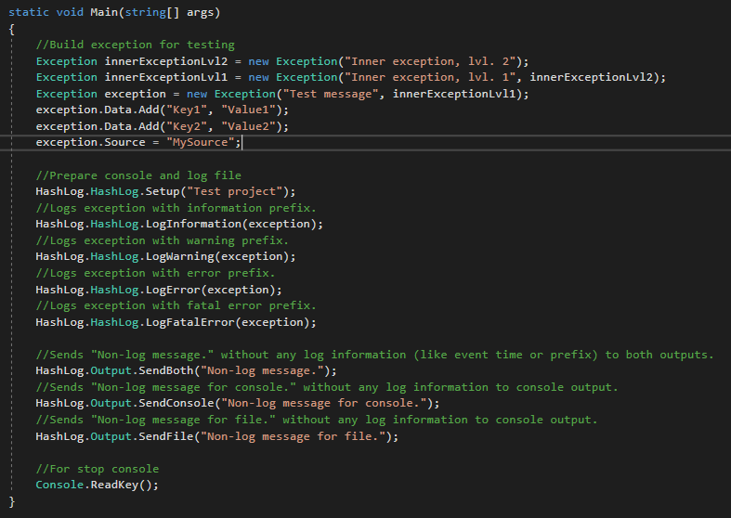

# API Documentation

## class HashLog

Class used to logging code events such as errors or doing important operations. Class will automatically add suitable prefix to log and actual system time to message.

Public Methods:

|  |  |  |
| --- | --- | --- |
| Name | Arguments | Description |
| static void Setup(string projectName) | string projectName – name of project used in log file and console title. | Method is doing setup of logger. Prepare log file and console. |
| static void LogInformation(Exception exception) | Exception exception – exception to log. | Logs exception with information prefix. |
| static void LogWarning(Exception exception) | Exception exception – exception to log. | Logs exception with warning prefix. |
| static void LogError(Exception exception) | Exception exception – exception to log. | Logs exception with error prefix. |
| static void LogFatalError(Exception exception) | Exception exception – exception to log. | Logs exception with fatal error prefix. |

## class Output

Class used to sending messages to console and file outputs of logger in unchanged form.

Public Methods:

|  |  |  |
| --- | --- | --- |
| Name | Arguments | Description |
| static void Setup(string projectName) | string projectName – name of project used in log file and console title. | Method is doing setup of logger outputs. Prepare log file and console. |
| static void SendBoth(string message[, bool newLineAtEnd = false]) | string message – message text.  bool newLineAtEnd – if true, HashLog’ll add additional newline character at end of the message (optional, default = false). | Writes message in original form from argument on both outputs. |
| static void SendConsole(string message[, bool newLineAtEnd = false) | -||- | Writes message in original form from argument on console output only. |
| static void SendFile(string message[, bool newLineAtEnd = false) | -||- | Writes message in original form from argument on file output only. |